**Experiment No. 5**

# Title: Proxy Chain Setup

**Roll No.: 16010420075 Experiments No.: 5**

# Aim: To set up proxy chain

\

**Resources:** virtual box

**Theory**

Proxychains are another tool for anonymity in Linux. Proxychains make anonymity and secure browsing simple. The proxychains support the protocols socks4, socks5, HTTP, and https. Proxychains are simple to set up, but many users experience problems when using them. Some of the most typical issues occur during tor installation, while others occur when the proxychain starts but you are not anonymous and your DNS leaks emerge.

**__________________________________________________________________________**

**IMPLEMENTATION AND RESULTS:**

1. Install tor using sudo apt install tor
2. Use command – start tor service
3. Show the status

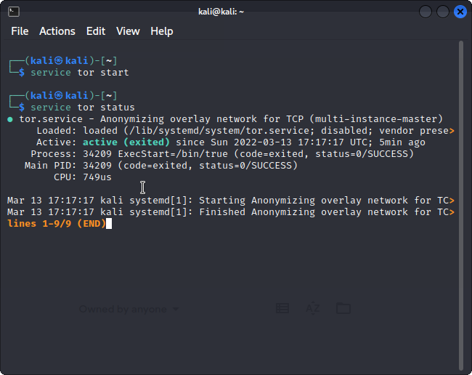

1. Open proxychains.conf file in edit mode (using root)

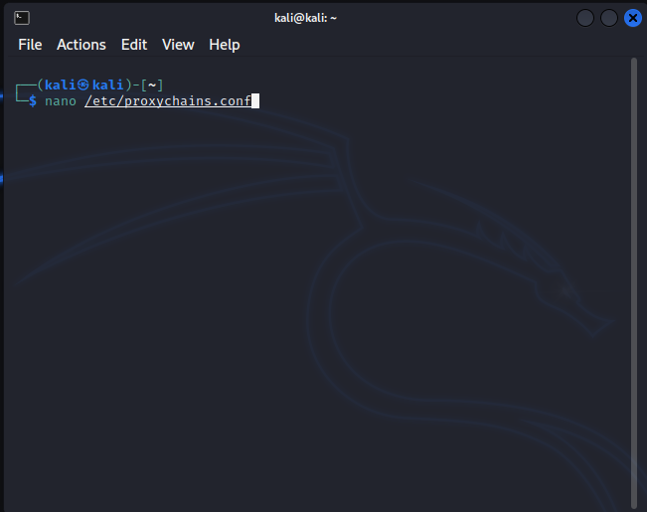

1. Scroll down till you find [ProxyList]

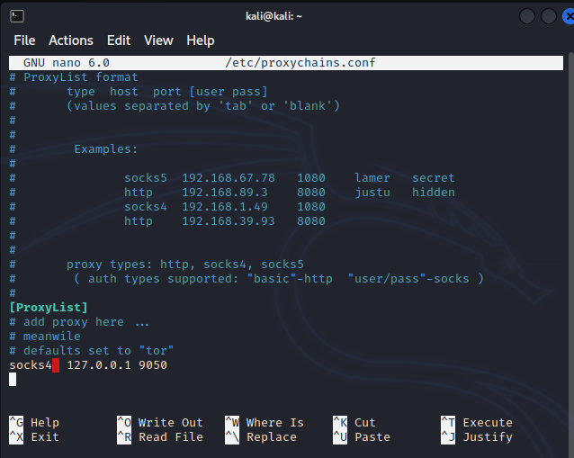

1. Go to [https://spys.one/en/](https://spys.one/en/free-proxy-list/) and select any proxy

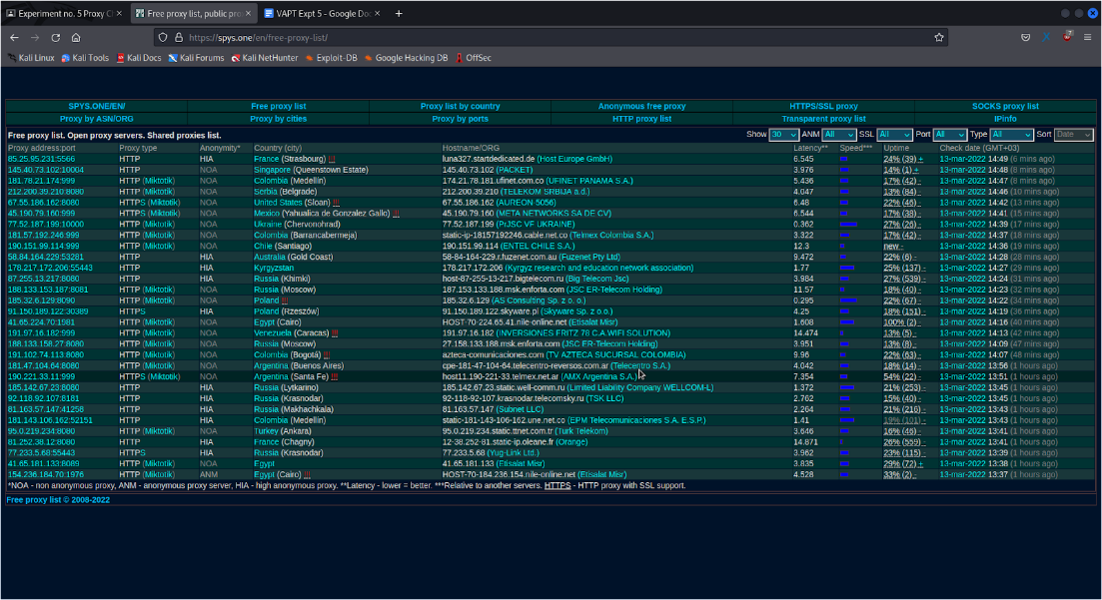

1. Enter the proxy in the proxy list

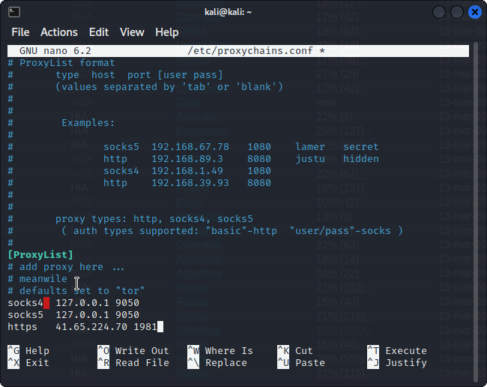

1. Open firefox using proxychains command in regular user mode

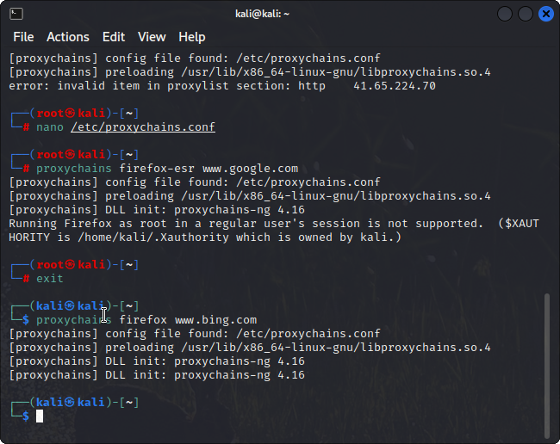



Proxychains is now set up!

**Outcomes:**

**CO-1:** Realize that premise of vulnerability analysis and penetration

testing (VAPT).

**_________________________________________________________________________**

**Conclusion: (Conclusion to be based on the objectives and outcomes achieved)**

Proxychains was set up and ready to use.

**Grade: AA / AB / BB / BC / CC / CD /DD**

**Signature of faculty in-charge with date**

**__________________________________________________________________________**

**REFERENCES:**

* [www.kali.org](http://www.kali.org)
* [www.spys.one/en](http://www.spys.one/en)